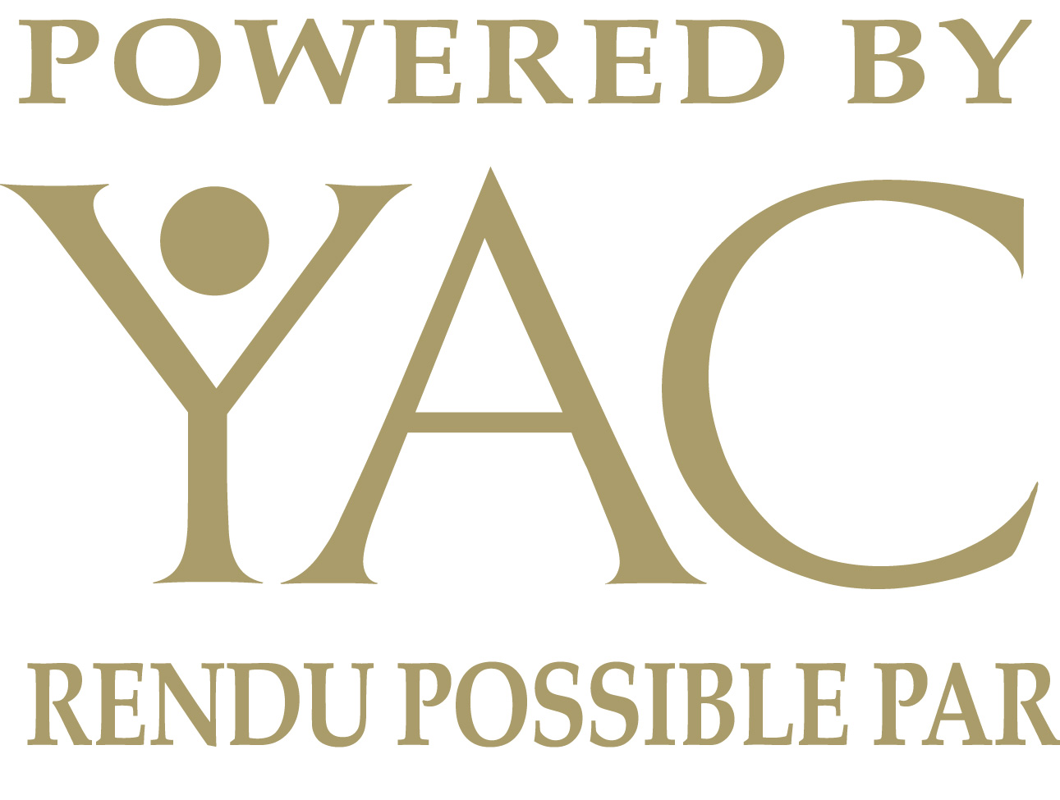
Guidelines & Application Form

The 30th Annual Apples & Art Studio Tour
September 25th & 26th, 2021

Submission Deadline: June 30th, 2021
We have decided to move ahead with plans to hold the Tour in 2021, and are reasonably confident Covid will be far enough in the rear-view mirror by then to make the in-person event possible. At the very least, you will be the featured artists on our new website. It is designed to be a useful search engine for artists all across the region all year round.
We invite all disciplines of artist to participate in the 2021, 30th edition of the tour. We look for a variety of visual, literary, glass, wood, textile, metal, sculpture, literary and multi-media artists. We are encouraging music, dance and theatre to look at adding to the venues. We are also encouraging students to participate at high school locations. We had a very successful year in 2019. With 85% of the artists reporting, the tour attracted more than 4,545 studio visitors who bought approximately $70,000 worth of art.
The entrance fee for the 2021 Tour is $90, to be billed after the deadline. DO NOT SEND PAYMENT AT THIS TIME. You must be a member of YAC to participate (click HERE or the ‘Become a Member’ button at yourartscouncil.ca – It’s FREE)
The tour is organized by volunteers working as a Standing Committee of Your Arts Council, Cornwall & the Counties. We are planning a 4- or 5-fold bilingual brochure showcasing the locations and artists, which will be published in July on our new website (and Facebook page), with the printed brochure following shortly thereafter. After that point, late-joiners to the tour will be added to the website only. A map of the sites listing artists will be posted on the brochure, Facebook page and website.
This application contains a release you must sign and terms you must acknowledge in order to participate.
Fees and Deadlines
The Artist's Application form and Insurance Waiver are at the end of this document, available at applesandart.ca and on the Apples & Art Facebook page. Please mail or email the completed application and insurance statement to richard@yourartscouncil.ca or by mail to Richard Salem at the address below. Do not make payment at this time.
Your enrollment is not accepted without a signed and completed application form. New artists to the tour must submit pictures of their creative works to the organizing committee for jurying. Returning artists must also submit new pictures of their creative works. The completed and signed Apples & Art application, no more than four digital pictures of your art, and a digital copy of your artist’s statement must be received by June 30, 2021.
Email: richard@yourartscouncil.ca
SnailMail: Apples & Art Studio Tour
c/o Richard Salem
21 Leonia Street
Cornwall ON K6H 5L5

Artist’s Statement
It is important to keep the Artist Statement under 200 words. If you need help, try asking yourself the following questions:
What is my artistic medium?
What am I trying to say or do with this medium?
What can my visitors expect to see when they visit?
ONLY 200 words. Please DO NOT send resumes, school records and certificates. Must be in the body of an email or text of some kind that can be copied and pasted as text.
Pictures
Four (4) images in jpg format representing your current work (web resolution, no bigger than 800 pixels in either dimension). Please send in new pictures of current work, or we will have to leave your page blank. If you don’t know how to change the name on a JPG file, get in touch, we can help.
The image names should be assigned in following format:
(Your NAME) - (TITLE OF PIECE) - (Medium).jpg
For example, Richard Salem’s artwork, titled “Bird in Flight”, made with acrylic paint on canvas, would be named:
Richard Salem – Bird in Flight – Acrylic on Canvas.jpg
Our new website uses tags, descriptive search terms people would enter to find you or your work. They already have your contact info available, but nothing on what you do. That’s what these tags are for. If you like painting Butterflies, ‘Butterflies’ would be a good tag. If the butterflies are part of a pastoral landscape, then pastoral and landscape are good tags too. Other good tags, assuming they’re appropriate, might be ‘Oil on Canvas’, framed, whatever you want to add that you think people might search for. Tell us what you want your tags to be. So, for each image, Please send the following information as text. The example is for the file above. The file name itself already contains your name, the painting title and the medium.
Filename: Richard Salem – Bird in Flight – Acrylic on Canvas.jpg
Suggested tags: Birds sky landscape large colourful Orphic Cubism framed
The better the tags you can come up with, the better your matches will be.

Jurying
All new artists to the tour are juried by the Apples & Art Studio Tour Committee. Jurors’ selections are based on the level of technical skill, quality of workmanship, and originality of design as represented by the images submitted. Not all applications will be accepted. The decision of the jurors is final.

Notification of Acceptance into the Tour will be by email no later than July 15th 2021
(for first time applicants only)

Responsibilities

Apples & Art Studio Tour Committee is responsible for:
- All administration
- Managing the budget and payments for Tour-related activities
- Creation of printed materials and signage
- Online promotion, social media and websites.
- Publicity, promotion, marketing and communication, and paid advertising within budget limitations
Artists are responsible for:
- Maintaining open studios both days, 10 a.m. to 4 p.m., being available to the public,
- Applications and support materials delivered on time and complete
- Distribution of artist's share of promotional material
- Picking up, posting, removing and returning of directional studio tour signs,
- Ensuring studio space is safe and prepared to welcome visitors
- Ensuring that the only art exhibited is the work created by the fee-paying artist
- Ensuring liability insurance for their own studio
- Keeping and reporting visitor statistics to the Tour Coordinator
Questions? Call or email Richard Salem (richard@yourartscouncil.ca or 1-888-405-7922 or 613-360-0485)
Application and Waiver follows.

Artist's Application Form for the 30th Annual Studio Tour

September 26 & 27, 2020

Submission Deadline: June 31st, 2021
Please Print legibly so we get it right!

Artist's Name: ______________________________________________________________________

Business/Studio Name for publication: ______________________________________________________________________

Your Mailing Address (correct google pointer): ______________________________________________________________________

Tel: ______________________________________(publish? Yes or No)
Cell: _____________________________________(publish? Yes or No)
Email: ____________________________________(publish? Yes or No)
Website: __________________________________(publish? Yes or No)

Your Medium: _____________________________________________________________________

ARE YOU Exhibiting at your address? YES NO
Sharing space this year is will be up to you to organize, let us know so we can spread the word.
If you have a location other than your own studio; you must have the permission of the owner of that space and have confirmed their participation in the Apples & Art Studio Tour. The Organizing Committee will NOT be inspecting and approving any proposed location, so safety issues are your responsibility.
Name of Contact, phone number and address of that location: _____________________________________________________________________
_____________________________________________________________________
_____________________________________________________________________
_____________________________________________________________________
_____________________________________________________________________

Is your site Wheelchair accessible: YES NO

Agreement
You agree that:
- We can use the images, biographical data, and emails, phone numbers, and addresses you provide and approve for publication purposes.
- You agree to be open to the public between the hours of 10 am and 4 pm on Saturday, September 25th and Sunday, September 26th, 2021.
- You agree not to use the Apples & Art branding on any advertising or promotion without prior approval from us.
- You agree to comply with the applicable EOHU guidelines for indoor in-person contact, if applicable, that are in place at the time of the event.
I have read and agree to comply with the requirements of the Apples & Art Studio Tour. Non-compliance with any of these conditions may result in exclusion from future Tours. Please keep a copy of this application for your records. In signing this application, the artist grants permission to the Apples & Arts Studio Tour to use any submitted photographs and social media content the event generates in promoting the event.

Applicant's Signature: ______________________________
Date: ________________________

Please mail or email this completed application and signed insurance waiver, along with your payment. You must confirm your location with Richard by email (richard@yourartscouncil.ca).

Apples & Art Studio Tour,
c/o Richard Salem
21 Leonia Street
Cornwall ON
K6H 5L5

Apples & Art Studio Tour 2020

Insurance Waiver
Artist: _____________________________________________________________________

Studio Name: _____________________________________________________________________

Apples & Art Studio Tour does not carry insurance for tour locations. Responsibility for insurance coverage, including public liability and property insurance for activities associated with the TOUR, is the responsibility of each participant.
Therefore, each participating artist is required to sign the following waiver.

I (print name) ______________________________, the undersigned, understand the following:
- Insurance coverage during the Apples & Art Studio Tour events, both public liability and property insurance, is my sole responsibility.
- I agree to release the Apples & Art Studio Tour and its organizers from any damages to personal property and/or personal injury which the artist, helpers or visitors sustain while participating in the Studio Tour.
- I agree not to use the Apples & Art Studio Tour name or logo for any self-promotion unless authorized in writing by the Apples & Art Studio Tour Organizing Committee.
Signature: ____________________________________
Date: ________________________________________

Please keep a copy of this waiver for your records.

